- Install Power BI Desktop and share the final screenshot of the report view page which appears when power desktop starts.
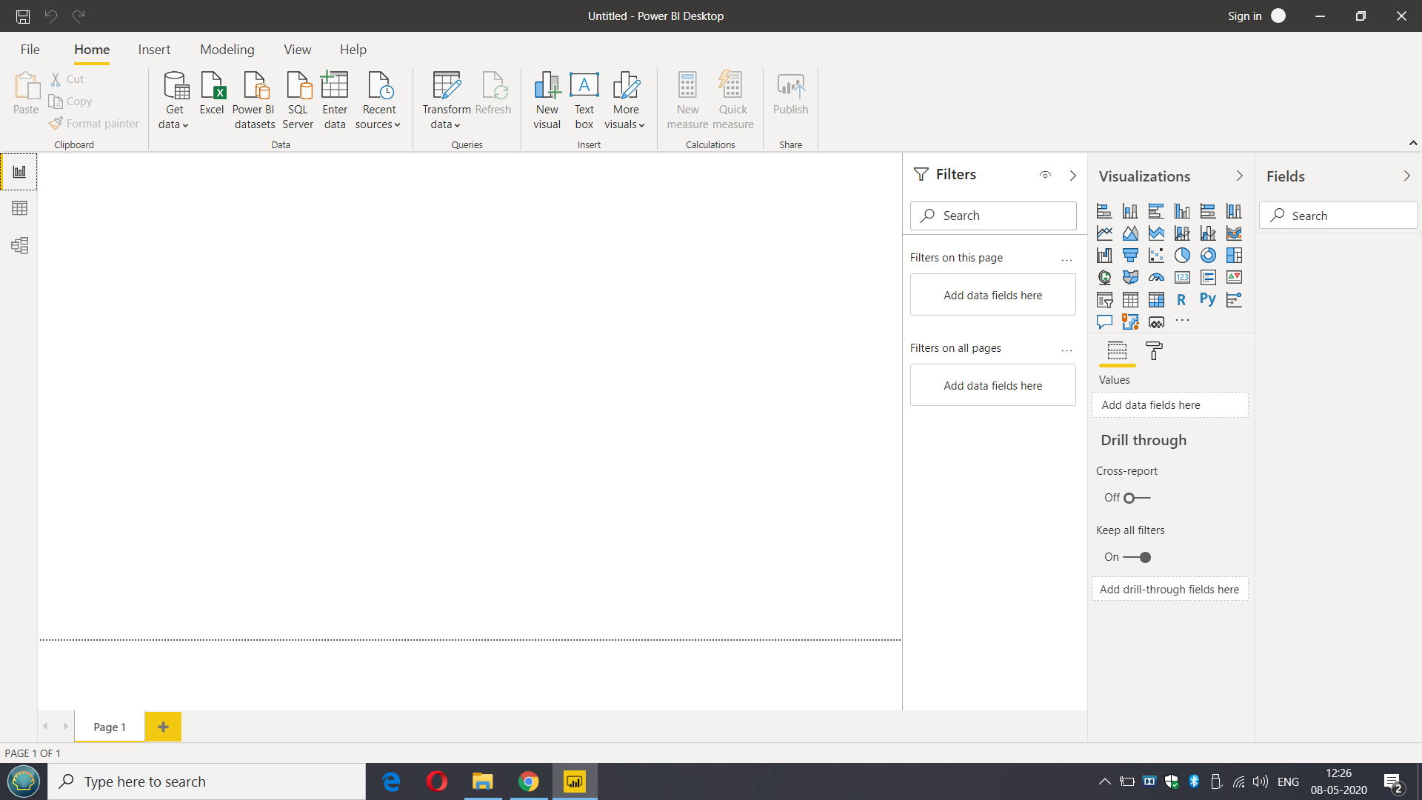

- Prepare a document and with the following screenshot
- Report View
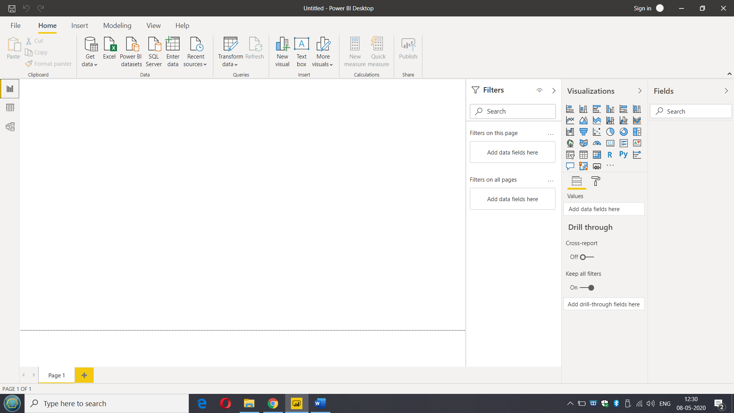

- Data View
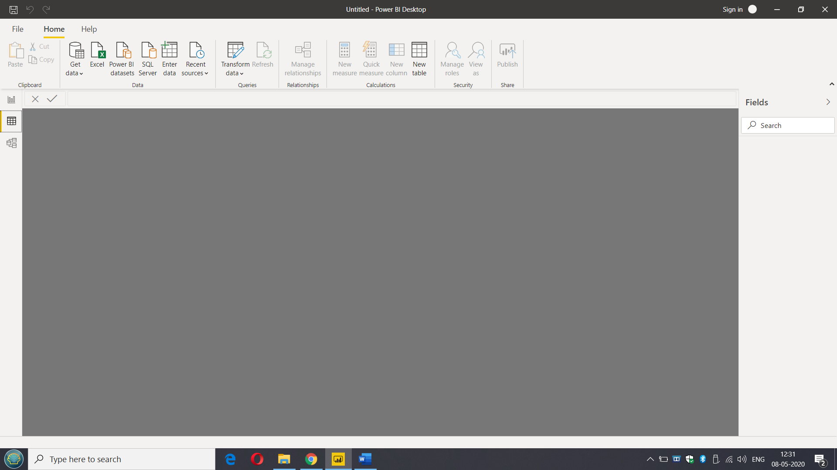

- Model View
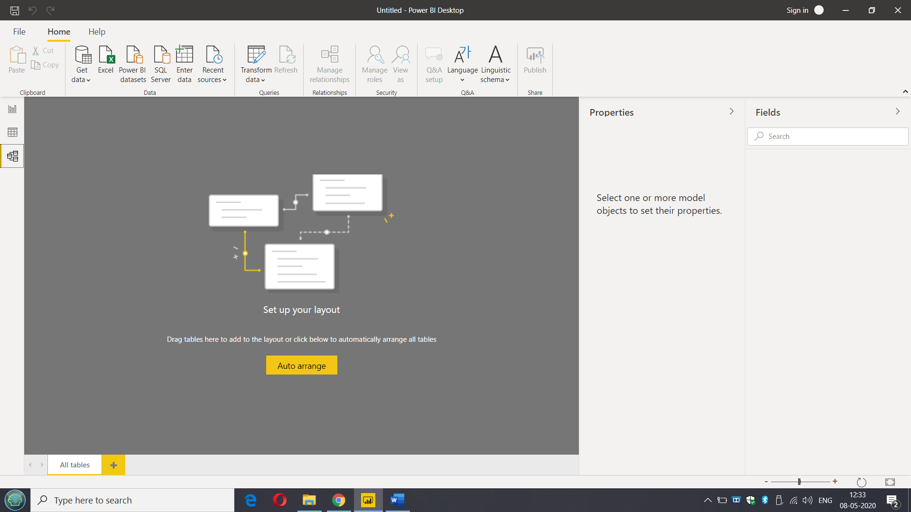

- Power Query Editor
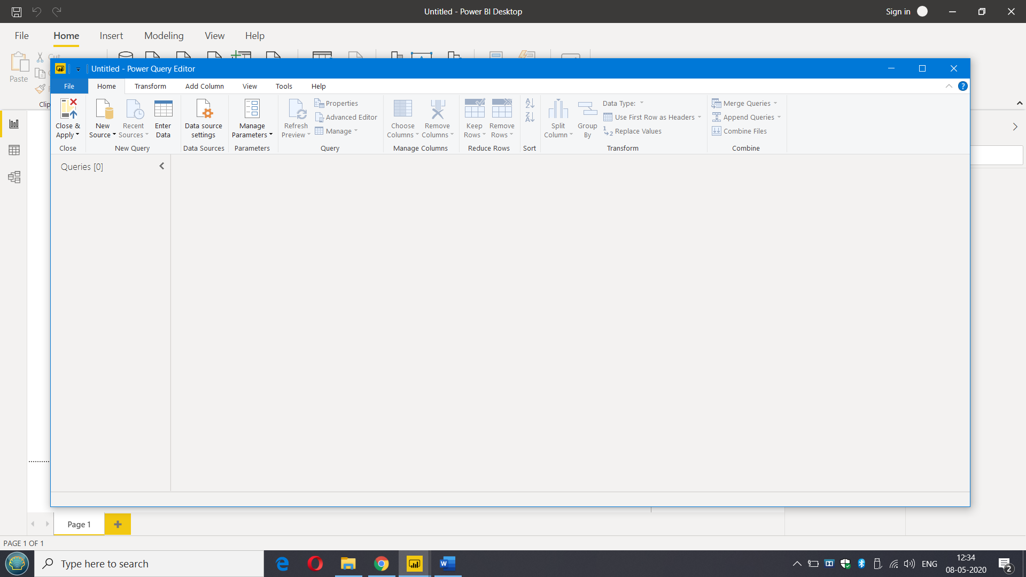

- Advance Editor
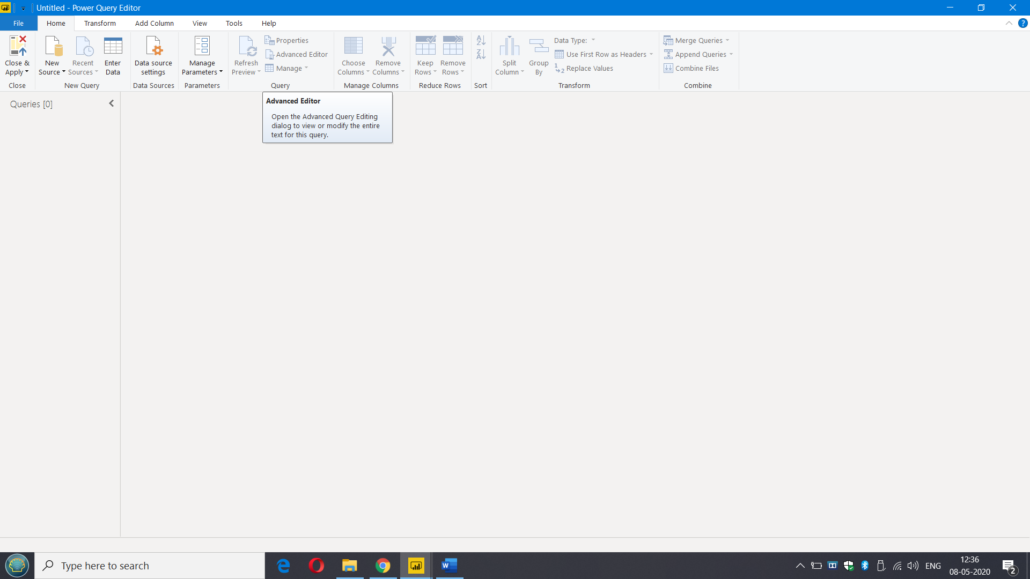

- Prepare a document with details of the following along with their price
- Power BI Desktop
Description :-
Power BI Free is included in all Office 365 Plans, and you can sign up for Power BI Free any time you like.
This free version is surprisingly functional. It allows you to connect to hundreds of data sources (no limit/restriction other than the amount of data you pull in), clean and prepare your data, and build visualizations (no limit). All of the types of visualization options in Power BI Pro are available in Power BI free.
Price :-
Free
- Power BI Pro
Description :-
Power BI Pro is an additional $9.99/user/month ($12.20 CAD). It is also included in Office 365 Enterprise E5. It adds a bunch of new features:
On-Premise Data Gateways-
If your data resides On-Premise (not somewhere in the cloud), you can now connect to this data and analyze it. A common example of this is a self-hosted SQL database.
More Data Storage-
Power BI Pro allows you up to 10 GB per Power BI Pro License. The free version caps you at 1GB per user.
Better Data Refreshes-
In Power BI Pro, you can better schedule data refreshes so that your team always has the latest version of your data.
Sharing and Collaboration-
The key feature here: If you want to share data, reports, and dashboards privately – you need to look at Power BI Pro.

Price :-
$9.99

- Power BI Premium
Description :-
It is not a type of user license. Think of it as an upgrade to your entire company’s capabilities. Organisations with Power BI Premium have a super-powered server running their Power BI environment; this allows them to surpass some limits. It is rather expensive ($5000-$20000/mo), so only the largest companies will get use out of it.
Separate Resources-
No more “noisy neighbours”. Power BI Premium gives you your own processing environment, so your Power BI operations can’t be slowed down by other users that aren’t even within your company.
More Storage-
Your company gets up to 100 TB of data storage to share in Power BI Premium.
Larger Datasets-
Power BI Premium allows you to work with datasets up to 50 GB in size.
Free User Sharing Access-
If you use Power BI Premium, then free users are able to consume shared dashboards.

Price :-
$4,995

